**Charter:**

**Introduction**

Our purpose is to work on a project to create a retro arcade game style chatroom app with gamification elements. The main purpose of the app is for people to be able to chat with each other in an entertaining manner. The primary audience of this app are gamers, especially gamers who are also fans of retro arcade games and their aesthetic. The secondary audience for this app is people who are interested in useful apps with gamification elements. Our tertiary audience will be people in need of a chat room or messaging apps in general. The context for people accessing this app should be those wanting to chat with others, or wanting to be entertained.

**Team Members:**

Steve Bateman, Bowen Condelario and Katie Greenwald

**Tasks:**

**Management Tasks:**Making and keeping a schedule. Regularly scheduling and attending meetings based on the schedule. Assigning tasks to team members. Documenting what was done in each meeting. Keep track of progress and regularly inform higher-ups of project status.

**Presentation:**

Making a presentation script. Presenting on the chatroom app’s unique appearance and features as a team.

**Required Tasks:**   
Create a Homepage. Create a Navbar. Create an about us page. Create a chatroom page. Create ability to set name and avatar. Create ability to create chatroom. Create ability to set chatroom to public or private. Create admin page. (lets us delete posts or rooms we don’t like, create new chatrooms etc. )Create ability to change background color/text color. Create ability to have conversation. Create ability to show list of users in room .  
  
**Bonus Tasks:**Create private messages capability. Create ability to see who is typing.  
 **Team Tasks:**Have ability to change colors include more backgrounds, text colors as and entire theme. Create ability to change text size. Create log in page. Create profile page.  
Create gamification features like levels and rewards for users and rooms. Create certain themes/backgrounds, avatar frames etc. that are limited to certain levels (roles?). Create an actual game? At least a gif for about page.

**Goals:**Get assignment done and on time. Be respectful of each other and be willing and able to listen to criticism. Create and follow a schedule. Assign and complete tasks in a timely manner. Meet all deadlines on time. Turn in work that meets the requirements and is of acceptable quality.

**General Roles:**Katie shall create and keep a schedule as well as take minutes.  
Making plans and assignment of tasks shall be decided as a group on a case by case basis.

**Personal goals and Individual commitment levels:**

Katie will take minutes and make and keep a schedule, she will do her best to learn from the assignment.

Steve:

Bowen:

**Other Concerns**

Team members shall not be penalized for lack of effort unless it crosses the line into negligence

Team members will attempt to split the work evenly among themselves.

Team members will work on quality control by having all members check each other’s work for errors at least once before submission and only after all members have approved the work as of acceptable quality should it be submitted.

**Conflict Resolution**

We will talk about the problem until we reach a general consensus on the issue. If a consensus cannot be reached through communication, we will approach the instructor for a solution. This will be done through emails or possibly discord PM’s within the group and with the instructor.

**Infractions:**

**Missed Deadlines:**

If an assigned task is not updated to the Github repository by the end of the scheduled deadline. Or if any team member does not inform the group in advance of a potential absence and work with the others to reschedule the deadline and or reassign their task to someone else.

**Unacceptable Work**

Work will be considered unacceptable if the final version of the work cannot compile or doesn’t meet the standards set by the instructor and or if the work is submitted without all members checking it out and discussing and performing corrections if bugs are found. Depending on the intention of the member who performed this infraction, penalties may include having to talk to the instructor and ask for redo or having to accept a grade penalty.

**Infraction Consequences:**   
First infraction will result in a warning, then a small deadline extension if possible. If others have to do their work or if there is a second infraction they will be considered negligent and the others will/may decide on a penalty which can include informing the higher-ups and discussing further options. Examples of this would be submitting work that is obviously rushed, sloppy and or doesn’t run. The first infraction will result in talking among the group for possible solutions to fix the problem and if a solution cannot be found, then we will refer to the instructor for possible future actions.

**Authorization**   
Members agreeing to uphold this charter and indicate their understanding and acceptance of its contents, will place their signatures below alongside the current date.

**Signatures:**

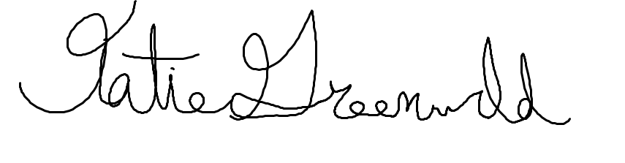

Katie Greenwald on December 2021

Steve Bateman on

Bowen Condelario on